R. Reports Menu: 2. Grantor Report

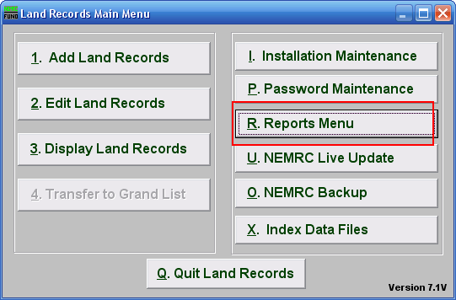
Click on “R. Reports Menu” from the Main Menu and the following window will appear:

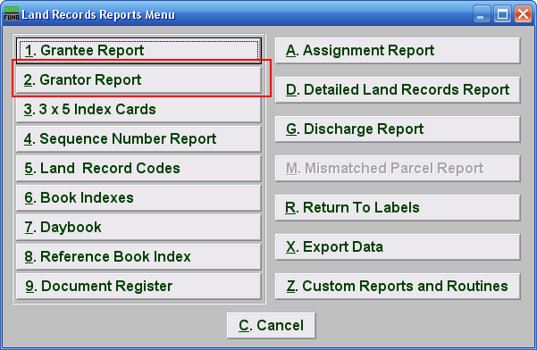
Click on “2. Grantor Report” from the Reports Menu and the following window will appear:
Grantor Report

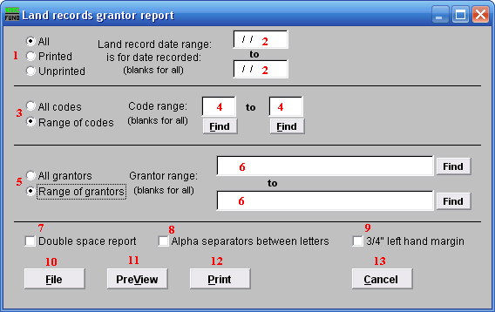

- All OR Printed OR Unprinted: Select the print status of records you wish to report.

- Land record date range is for date recorded: Enter the beginning and ending date range for data to report. Leaving these fields empty will result in all available data being selected.

- All OR Range of codes: Select the choice of reporting on all codes or a specific range of codes.

- Code range: Enter a specific range of codes to report or leave these fields empty to report on all codes. You may pick your start and ending ranges from a list by using the find button.

- All OR Range of grantors: Select the choice of reporting on all grantors or a specific range of grantors.

- Grantor range: Enter the specific range of grantor names to report. You may pick your start and ending ranges from the list by using the find button.

- Double space report: Click this box to have this report be double-spaced instead of single-spaced. This is for marking up or visual appearance.

- Alpha separators between letters: Check this box to have the system create a break in the listings between changes in the first letter of the name.

- 3/4" left hand margin: Check this box to have the system create a three quarter inch left margin for binding of the report.

- File: Click this button to save this report on this computer. Refer to GENERAL FILE for more information.

- PreView: Click this button to preview this report. Refer to GENERAL PREVIEW for more information.

- Print: Click this button to print this report. Refer to GENERAL PRINTING for more information.

- Cancel: Click “Cancel” to cancel and return to the Reports Menu.

